Horizontal Pod Autoscaler deployment in Kuberneties:

=======================

GIT URL:

=====

https://github.com/ashokitschool/k8s_metrics_server/tree/main/deploy/1.8%2B

https://github.com/kubernetes-sigs/metrics-server

Kubernetes Metrics Server

=========

Metrics-server aggregates resource consumption data like CPU and memory usage for Kubernetes nodes, pods and containers. These metrics are collected from the API exposed by the Kubelet on each node.

The metrics server is commonly used by other Kubernetes add ons, such as the Horizontal Pod Autoscaler or the Kubernetes Dashboard.

It is not deployed by default.

Deployment

======

In order to deploy metrics-server in your kubernetes master machine clone https://github.com/ashokitschool/k8s_metrics_server.git and run the following command from the top-level directory(metrics-server) of this repository:

$ kubectl apply -f deploy/1.8+/

Usage

# Display node metrics

$ kubectl top nodes

# Display pod metrics

$ kubectl top pods

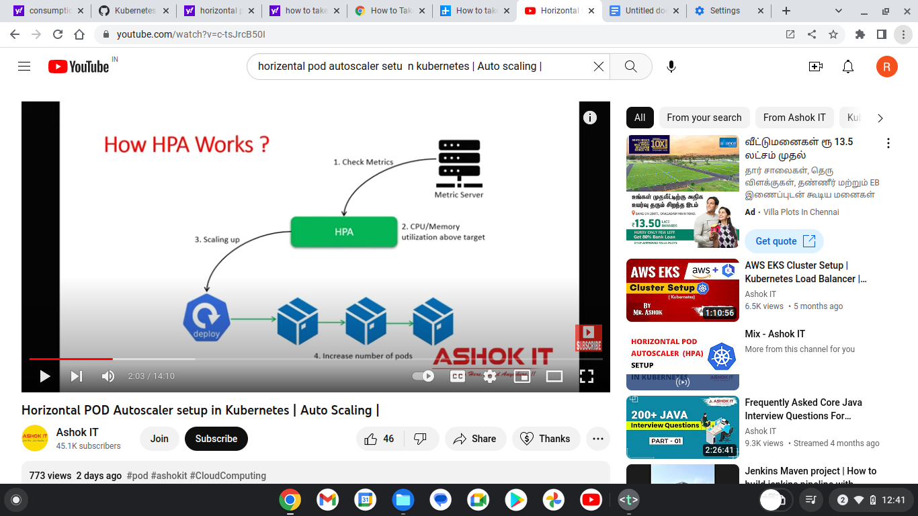

Go to linux machine and start setup:

Deployment

======

In order to deploy metrics-server in your kubernetes master machine clone https://github.com/ashokitschool/k8s_metrics_server.git and run the following command from the top-level directory(metrics-server) of this repository:

$ kubectl apply -f deploy/1.8+/

Usage

# Display node metrics /worker nodes

$ kubectl top nodes

# Display pod metrics/metrics server is working or not

$ kubectl top pods

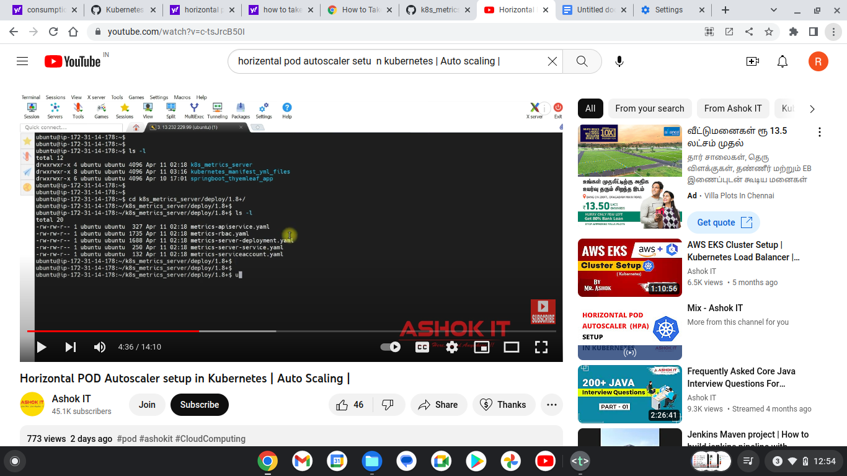

=======================

Step1 : how to install metrics server:

====================

https://github.com/ashokitschool/k8s_metrics_server/tree/main/deploy/1.8%2B

clone project and then

go to this path :

cd k8s_metrics_server/tree/main/deploy/1.8

ls -l --> you can see all yaml files here

$ kubectl apply -f . ->> to yaml files will execute using apply command. then metrics server is installed after execute apply.

you can check using this command : kubectl top pods

========================

Step 2: now deploy my application to see pods /resources.

=========================

https://github.com/ashokitschool/kubernetes_manifest_yml_files/tree/main/05-HPA

clone from github manifest yml files to deploy application

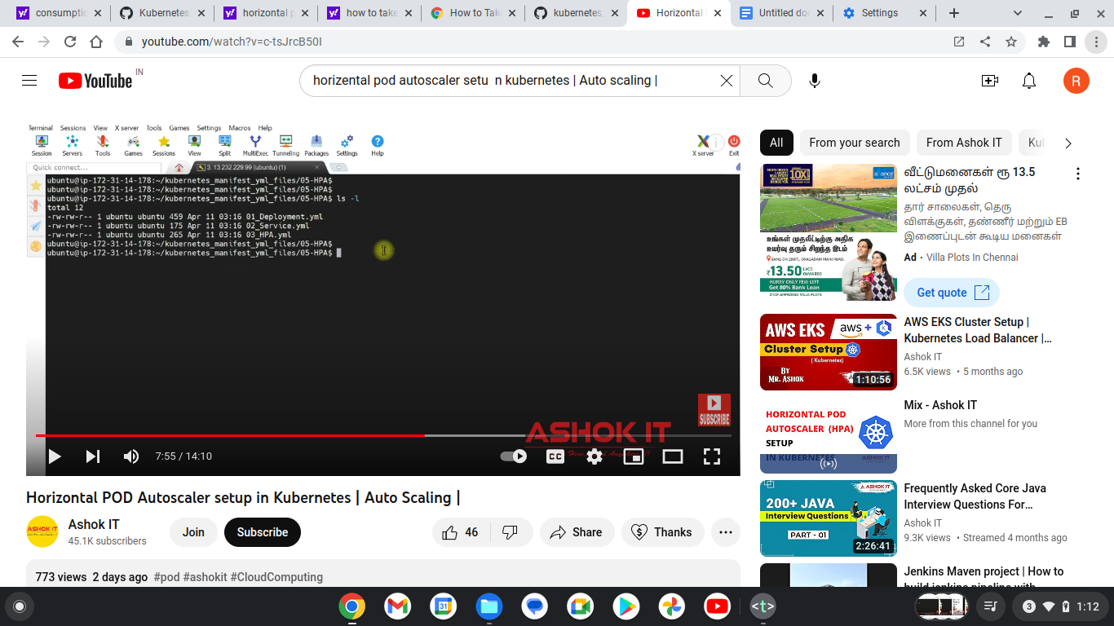

========================

Step 2: now deploy my application to see pods /resources.

=========================

https://github.com/ashokitschool/kubernetes_manifest_yml_files/tree/main/05-HPA

clone from github manifest yml files to deploy application

cd kubernetes_manifest_yml_files/05-HPA/

$ kubectl apply -f 01_Deployment.yml

$ kubectl get deploy --> to see whether app deployed or not.

$ kubectl apply -f 02_Service.yml

$ kubectl apply -f 03_HPA.yml

kubectl get svc

kubectl get hpa

once deployment is created , if you want to see load increase we can use busy box using below commnad

to increse the load using busy box:

$ kubectl run -i --tty load-generator --rm --image=busybox --restart=Never --/bin/sh -c "while sleep 0.01; do wget -q -O- http://hpa-demo-deployment;done"

$ kubectl get hpa -w

$ kubectl describe deploy hpa-demo-deployment

$ kubectl get hpa

$ kubectl get events